# Name: Apurba Koirala

# Reg no: 22BCE3799

# Subject Code: BCSE302P

# Course Title: Database Systems

# Lab Slot: L33 + L34

# Guided by: Dr. Shashank Mouli Satapathy

**QN.1**

For the relational schema given as part of Assessment – 1, write the SQL queries to get the following information.

1) Find the employee who is getting highest salary in the department research

**QUERIES:**

SELECT * FROM employee WHERE DEPNO = 5

ORDER BY SALARY DESC FETCH FIRST ROW ONLY;

**OUTPUT:**

2) Find the employees who earn the same salary as the minimum salary for each Department

**QUERIES:**

SELECT e.*

FROM employee e

JOIN (

SELECT DEPNO, MIN(SALARY) AS min_salary

FROM employee

GROUP BY DEPNO

) min_salaries ON e.DEPNO =

min_salaries.DEPNO AND e.SALARY =

min_salaries.min_salary;

**OUTPUT:**

3) Find the employee whose salary is greater than average salary of department 2

**QUERIES:**

SELECT *

FROM employee

WHERE SALARY > (

SELECT AVG(SALARY)

FROM employee

WHERE DEPNO = 2

);

**OUTPUT:**

4) List out all the department names with their individual employees strength

**QUERIES:**

SELECT d.DNAME, COUNT(e.SSN) AS

employee_count

FROM dept d

LEFT JOIN employee e ON d.DEPNO =

e.DEPNO

GROUP BY d.DNAME;

**OUTPUT:**

5) Find out the department name having highest employee strength

**QUERIES:**

SELECT d.DNAME, COUNT(e.SSN) AS

employee_count

FROM dept d

LEFT JOIN employee e ON d.DEPNO =

e.DEPNO

GROUP BY d.DNAME

ORDER BY employee_count DESC

FETCH FIRST ROW ONLY;

**OUTPUT:**

6) List out all the departments and average salary drawn by their employees

**QUERIES:**

SELECT d.DNAME, AVG(e.SALARY) AS

average_salary

FROM dept d

LEFT JOIN employee e ON d.DEPNO =

e.DEPNO

GROUP BY d.DNAME;

**OUTPUT:**

7) Find maximum average salary for each department.

**QUERIES:**

SELECT department_avg_salaries.DNAME,

MAX(avg_salary)

AS max_avg_salary

FROM (

SELECT d.DNAME, AVG(e.SALARY) AS avg_salary

FROM dept d

LEFT JOIN employee e ON d.DEPNO =

e.DEPNO

GROUP BY d.DNAME

) department_avg_salaries

GROUP BY department_avg_salaries.DNAME;

**OUTPUT:**

8) Create a view to display the employee details who is working in Finance department.

**QUERIES:**

CREATE VIEW FIN_EMP AS

SELECT *

FROM employee

WHERE DEPNO = 4;

SELECT * FROM FIN_EMP;

**OUTPUT:**

9) Create a logical table to store employee details who is getting salary more than 10000.

**QUERIES:**

CREATE VIEW HighSalaryEmp AS

SELECT * FROM employee

WHERE SALARY > 10000;

SELECT * FROM HighSalaryEmp;

**OUTPUT:**

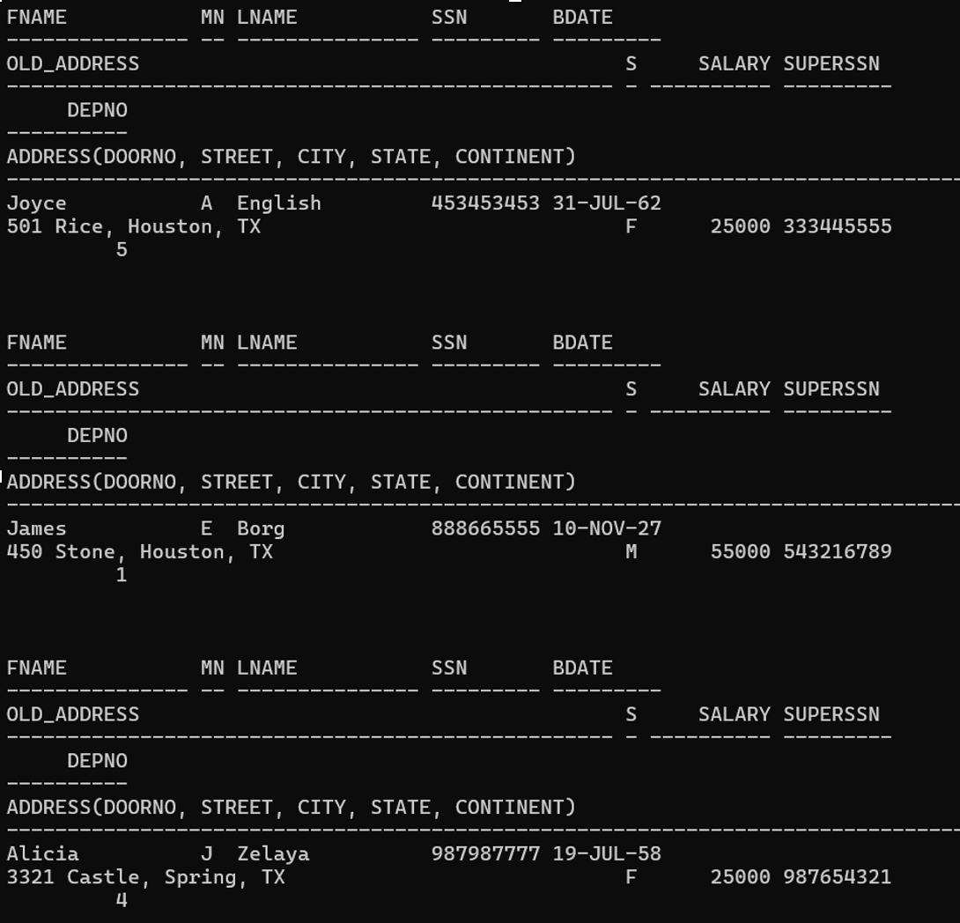

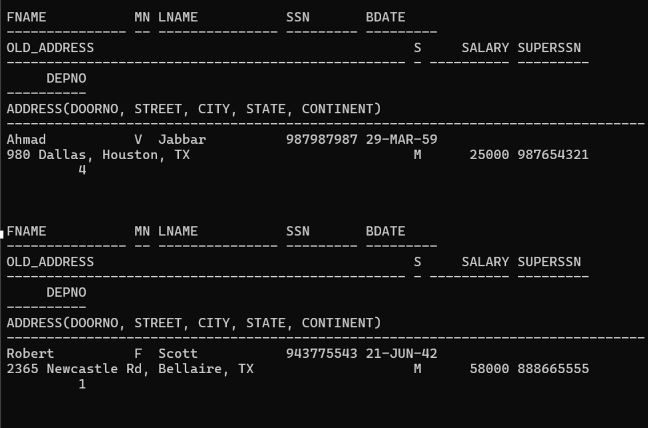

10) Create a table to store the employees details based on the department no.

**QUERIES:**

CREATE TABLE DepartmentEmployees AS

SELECT *

FROM employee

ORDER BY DEPNO;

SELECT * FROM DepartmentEmployees;

**OUTPUT:**

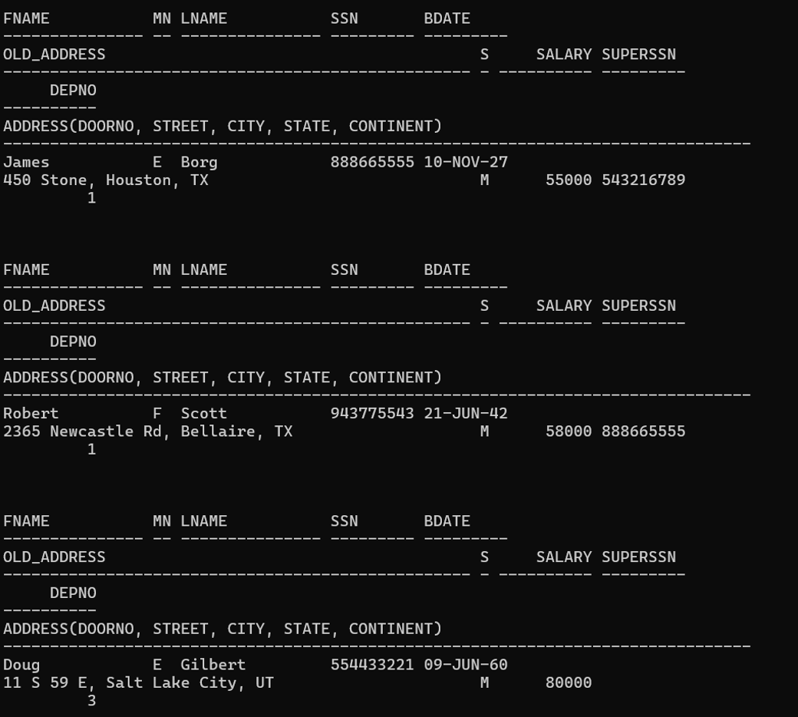

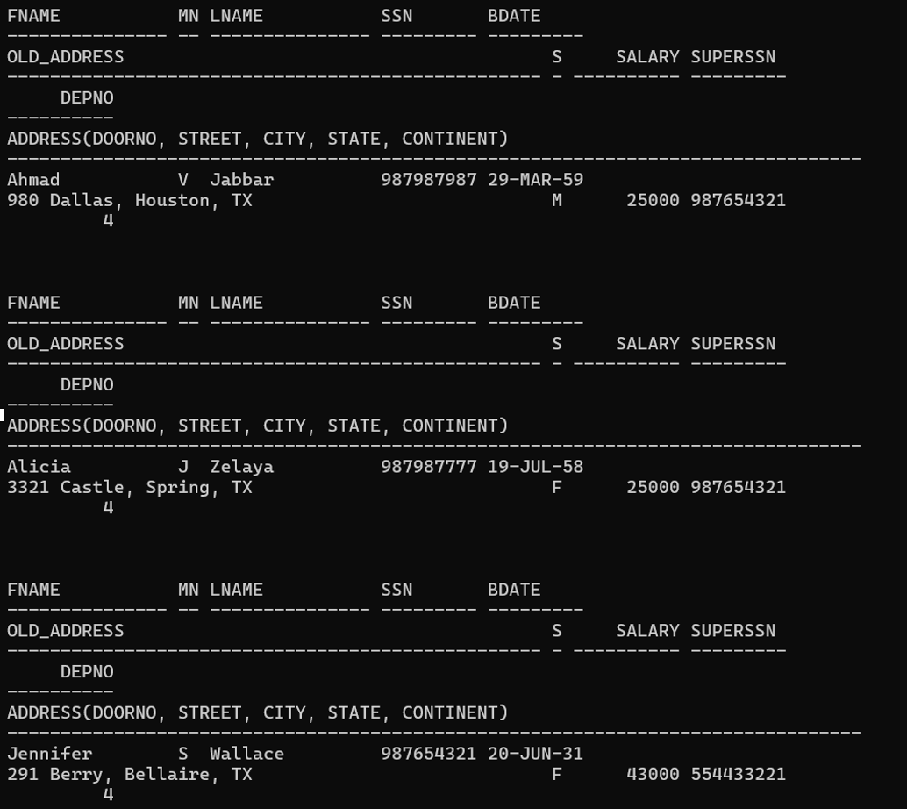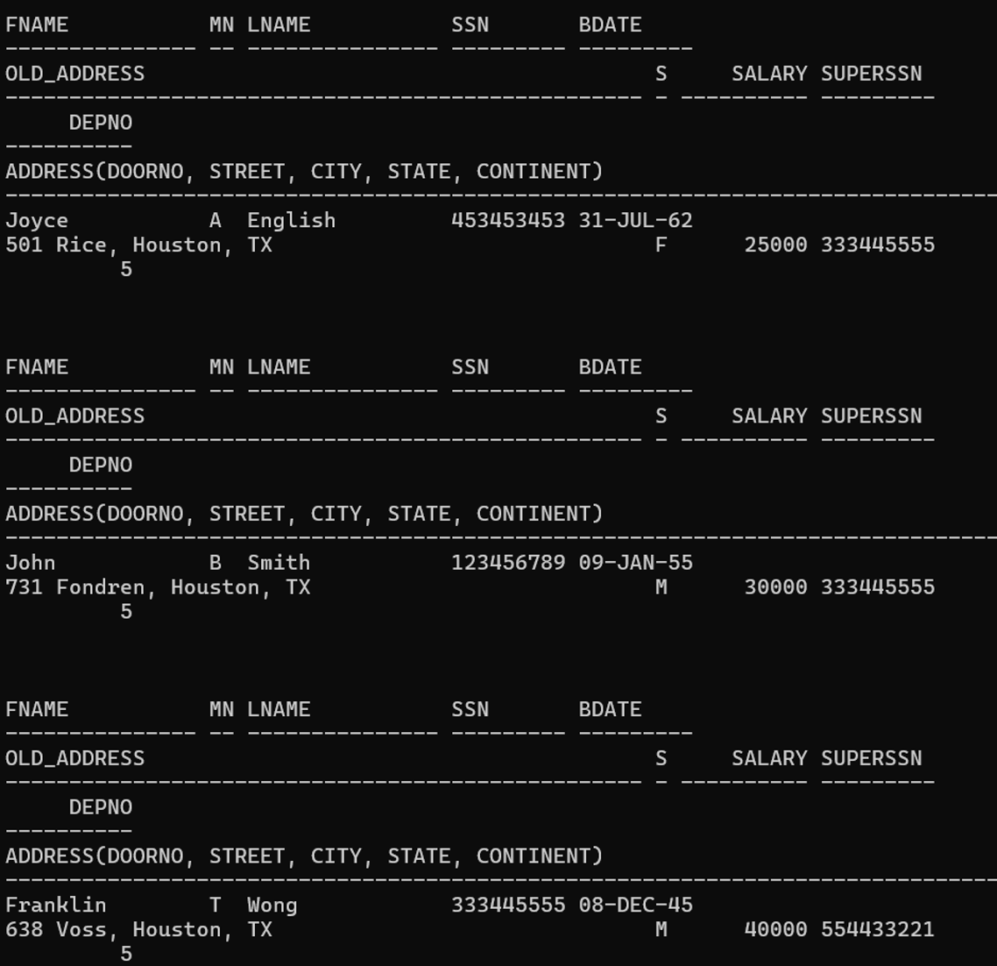

**QN.2**

For the relational schema given as part of Assessment – 1, write the SQL queries using joins to get the following information.

1) Retrieve the names of all employees in department 5 who work more than 10 hours per week on ProductX project.

**QUERIES:**

SELECT e.FNAME, e.LNAME

FROM employee e

JOIN works_on w ON e.SSN = w.ESSN

JOIN project p ON w.PNUMBER = p.PNUMBER

WHERE e.DEPNO = 5

AND w.HOURS > 10

AND p.PNAME = 'ProjectX';

**OUTPUT:**

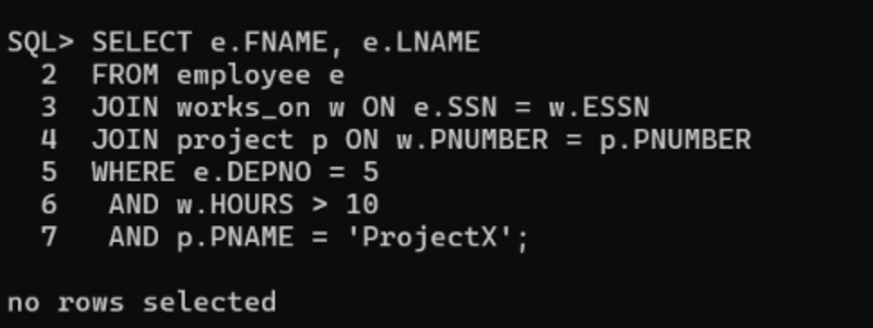

2) List the names of all employees who have a dependent with the same first name as themselves.

**QUERIES:**

SELECT e.FNAME, e.LNAME

FROM employee e

JOIN dependent d ON e.SSN = d.ESSN

WHERE d.DEPENDENTNAME = e.FNAME;

**OUTPUT:**

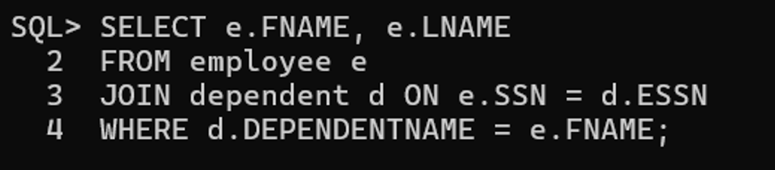

3) Find the names of all the employees who are directly supervised by ‘Franklin Wong’.

**QUERIES:**

SELECT e.FNAME, e.LNAME

FROM employee e

JOIN employee s ON e.SUPERSSN = s.SSN

WHERE s.FNAME = 'Franklin' AND s.LNAME = 'Wong';

**OUTPUT:**

4) Retrieve the names of all who do not work on any project.

**QUERIES:**

SELECT FNAME, LNAME

FROM employee

WHERE SSN NOT IN (SELECT ESSN FROM works_on);

**OUTPUT:**

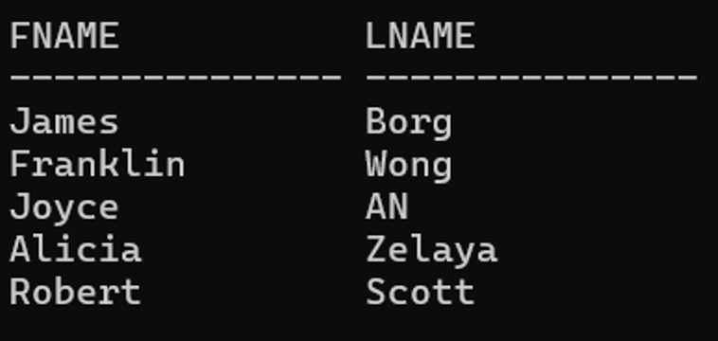

5) Find the names and addresses of all employees who work on at least one project located in Houston but whose department has no location in Houston.

**QUERIES:**

SELECT e.FNAME, e.LNAME, e.OLD_ADDRESS

FROM employee e

JOIN works_on w ON e.SSN = w.ESSN

JOIN project p ON w.PNUMBER = p.PNUMBER

JOIN dept_locations d ON e.DEPNO = d.DEPNO

WHERE p.PLOCATION = 'Houston' AND d.DLOCATION <> 'Houston';

**OUTPUT:**

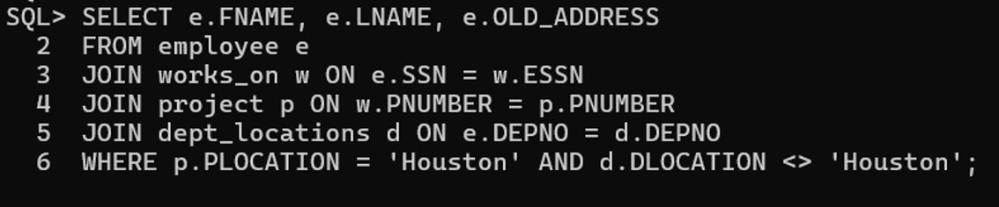

6) List the names of all managers who have no dependents.

**QUERIES:**

SELECT e.FNAME, e.LNAME

FROM employee e

JOIN dept d ON e.SSN = d.MGRSSN

WHERE NOT EXISTS (

SELECT 1

FROM dependent dep

WHERE dep.ESSN = d.MGRSSN

)

**OUTPUT:**

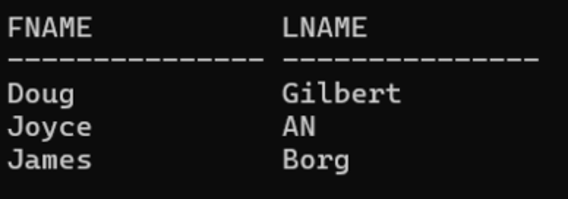

7) List the employee’s names and the department names if they happen to manage a department.

**QUERIES:**

SELECT e.FNAME, e.LNAME, d.DNAME

FROM employee e

JOIN dept d ON e.SSN = d.MGRSSN;

**OUTPUT:**

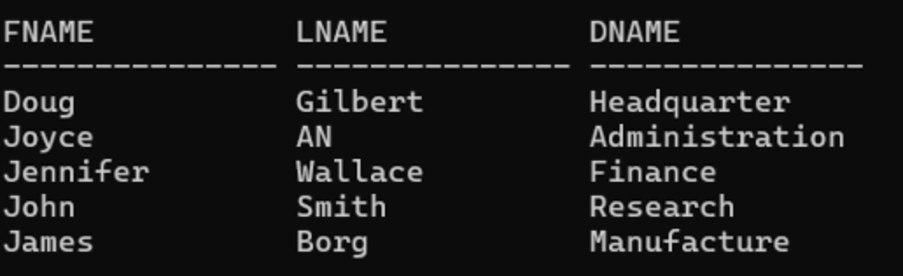

8) For each project retrieve the project number, project name and the number of employees who work on that project.

**QUERIES:**

SELECT p.PNUMBER, p.PNAME, COUNT(w.ESSN)

AS num_employees

FROM project p

LEFT JOIN works_on w ON p.PNUMBER = w.PNUMBER

GROUP BY p.PNUMBER, p.PNAME;

**OUTPUT:**

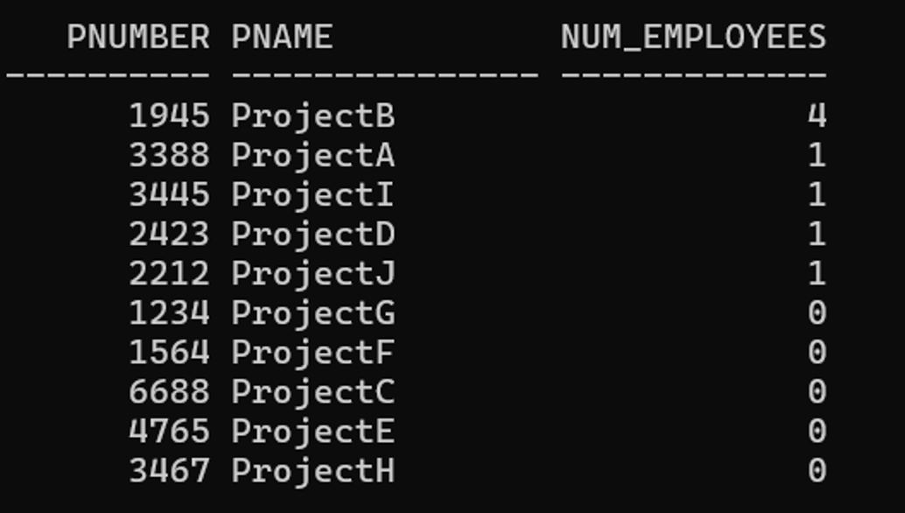

9) For each project, list the project name and the total hours per week (by all employees) spent on that project.

**QUERIES:**

SELECT p.PNAME, SUM(w.HOURS) AS total_hours_per_week

FROM project p

JOIN works_on w ON p.PNUMBER = w.PNUMBER

GROUP BY p.PNAME;

**OUTPUT:**

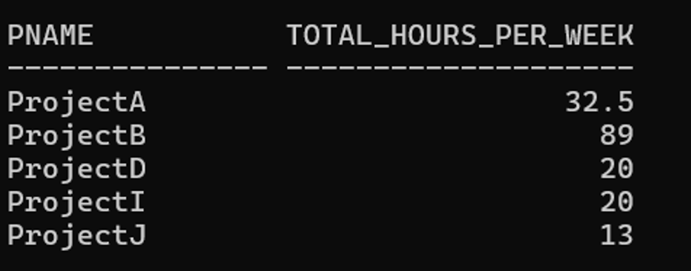

10) Retrieve the names of the employees who have 2 or more dependents.

**QUERIES:**

SELECT e.FNAME, e.LNAME

FROM employee e

JOIN (

SELECT ESSN, COUNT(*) AS num_dependents

FROM dependent

GROUP BY ESSN

HAVING COUNT(*) >= 2

) d ON e.SSN = d.ESSN;

**OUTPUT:**

